ST-3 Summary

ST-3 Test Stats | #
Test cases planned for this sprint | 2
Test cases COMPLETED (without errors) | 0 | WHICH FR?
Test cases NOT COMPLETED | 2 | WHY? | FR 9.1: Unsuccessful; Timestamp has wrong date/time on Notification page  FR 9.2: Partially successful; Homepage and Notification page mismatch
DEFECTS found | 0 | STATUS:

FR 9.1, 9.2
STP Test Case # ST-3
Requirement tested: FR-9.1
Description: The system shall record the timestamp when a worklog is submitted.
Build: v0.2.0_20260325
Determination: UNSUCCESSFUL

Setup:

- Open Chrome browser on Windows OS
- Navigate to front-facing Moxie server (http://moxie.cs.oswego.edu:7000/)
- Execute test

Execution:

- Log in as a student.
- Navigate to the Worklogs page.
- Fill in required worklog fields.
- Click Submit Worklog.
- Open the submitted worklog (or submission confirmation/details page).
- Observe the submission timestamp shown.

Expected Result:

User should be able to submit a worklog and see that the system records a submission timestamp, and the timestamp shown should match the date/time the worklog was submitted.

Actual Result:

When a worklog is submitted, the homepage lists the submission with a correct date but no time was shown (Screenshot 1)

When I clicked on “View All” (Screenshot 2), it listed my worklog submission but had the wrong date and time. The date/time should have read: March 26, 12:30pm.

Screenshot # 1:
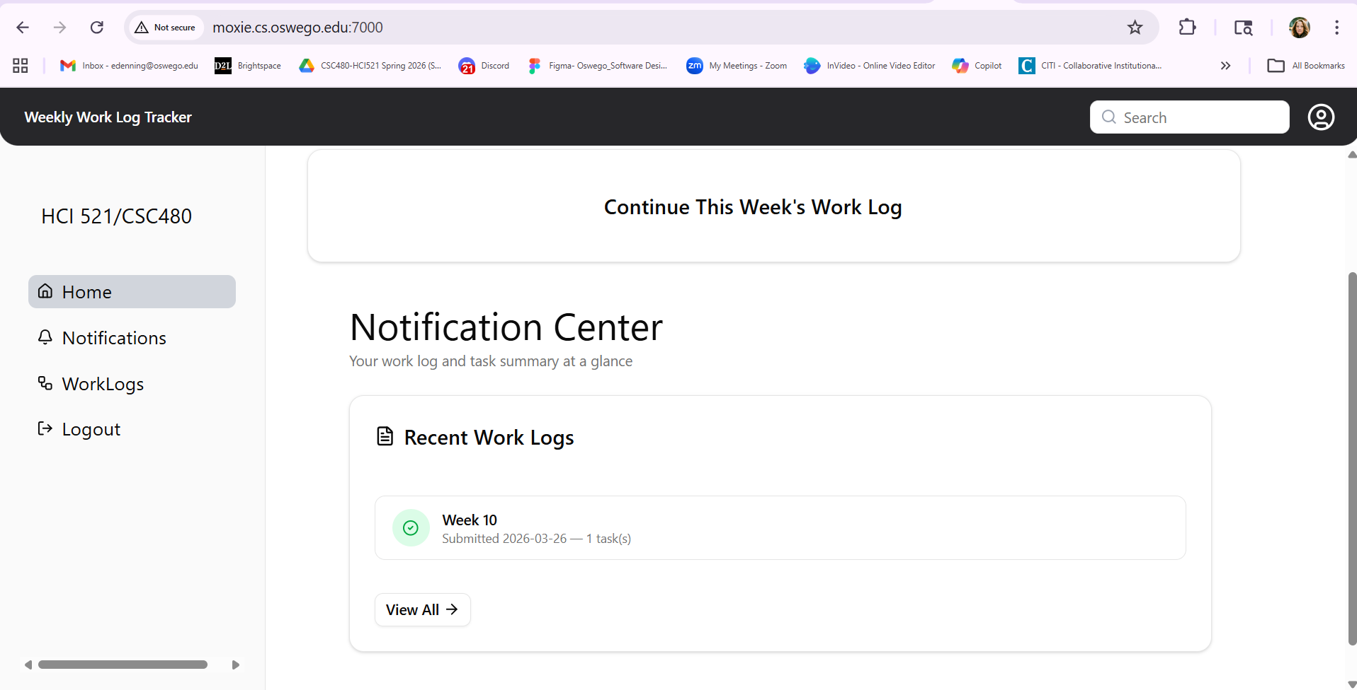

Screenshot # 2:
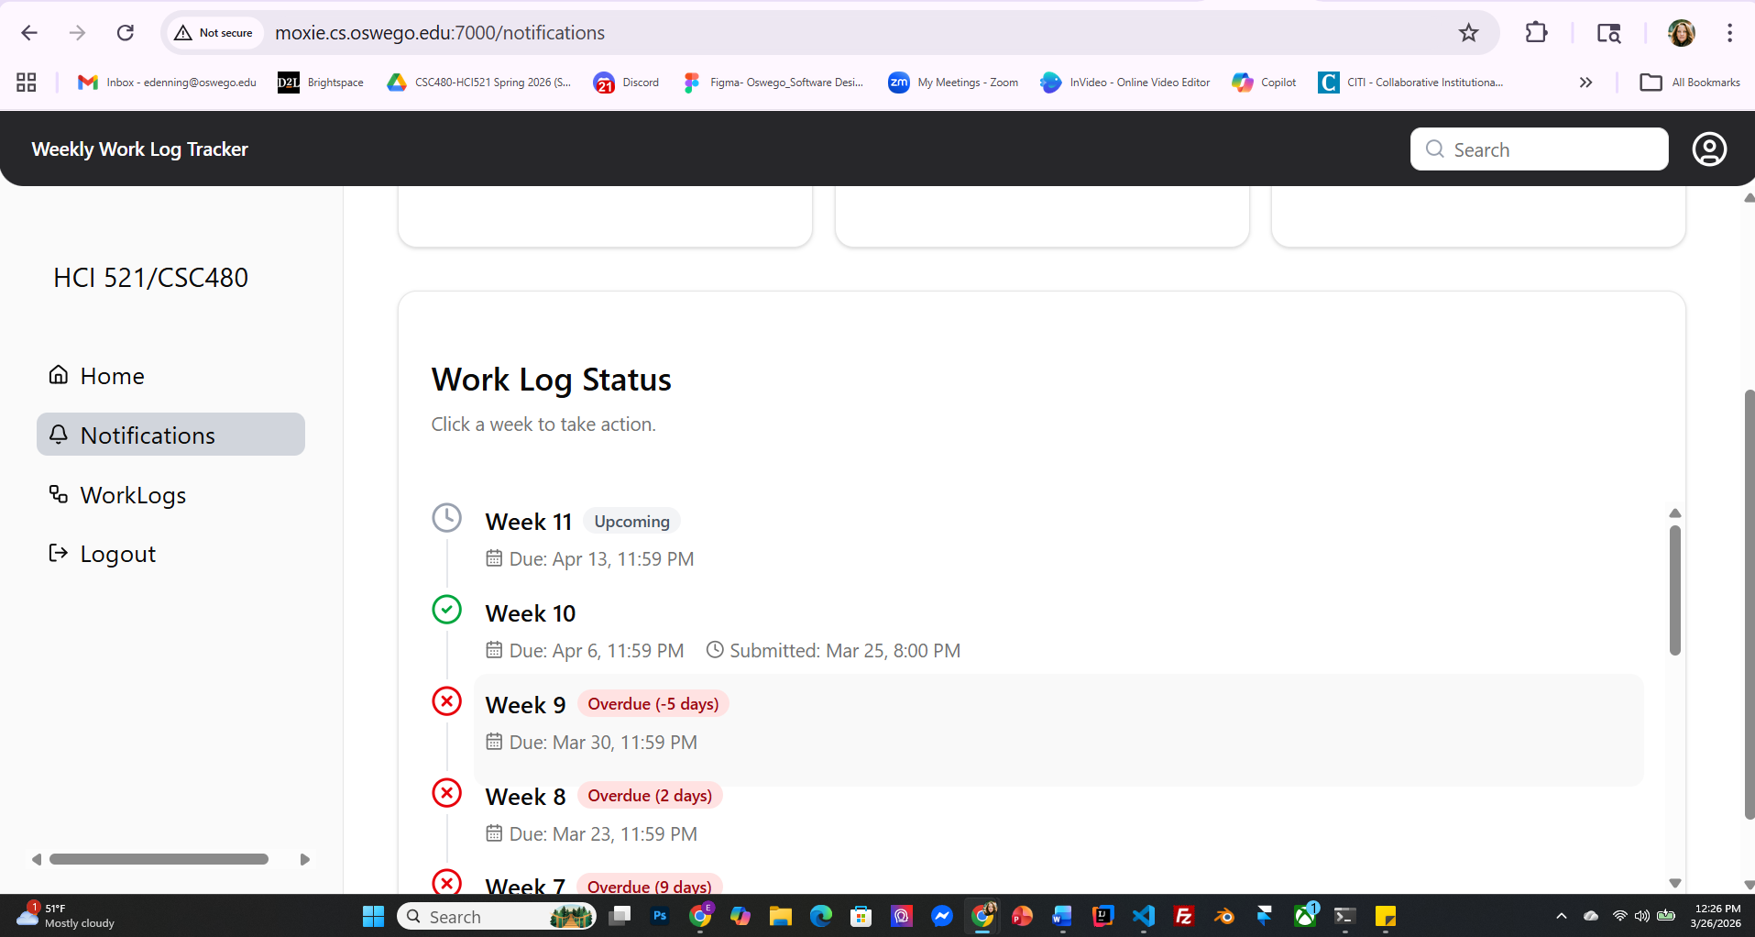

STP Test Case # ST-3
Requirement tested: FR-9.2
Description: The system shall compare the submission timestamp with the worklog deadline.
Build: v0.2.0_20260325
Determination: PARTIALLY SUCCESSFUL
Setup:
- Open Chrome browser on Windows OS
- Navigate to front-facing Moxie server (http://moxie.cs.oswego.edu:7000/)
- Execute test
Execution:
- Log in as a student.
- Navigate to the Worklogs page.
- Locate the worklog deadline for the current reporting period.
- Fill in required worklog fields.
- Click Submit Worklog.
- Observe the submission status (on-time/late).
Expected Result:
User should be able to submit a worklog and see that the system compares the submission timestamp with the worklog deadline and displays the correct submission status (on-time or late).
Actual Result:
There seems to be a disconnect between the content on the Notifications page and the homepage.
The notification page displayed that Worklog 9 was overdue by 5 days. When submitting a worklog for that overdue notification, the system did not indicate that my submission was overdue. However, the “due date” on the Notification page says March 30th, which is still in the future so it’s confusing that it would say it’s overdue if it’s not.
For Week 8, the due date was March 23rd, which is in the past so when I submitted a worklog for Week 8, it successfully displayed on the Notifications page that it was overdue.
The homepage just stated what submissions I had turned in without saying whether it was late or not.

Screenshot # 1:
I selected Week 9 to fill out a worklog which indicated that it was overdue by 5 days.
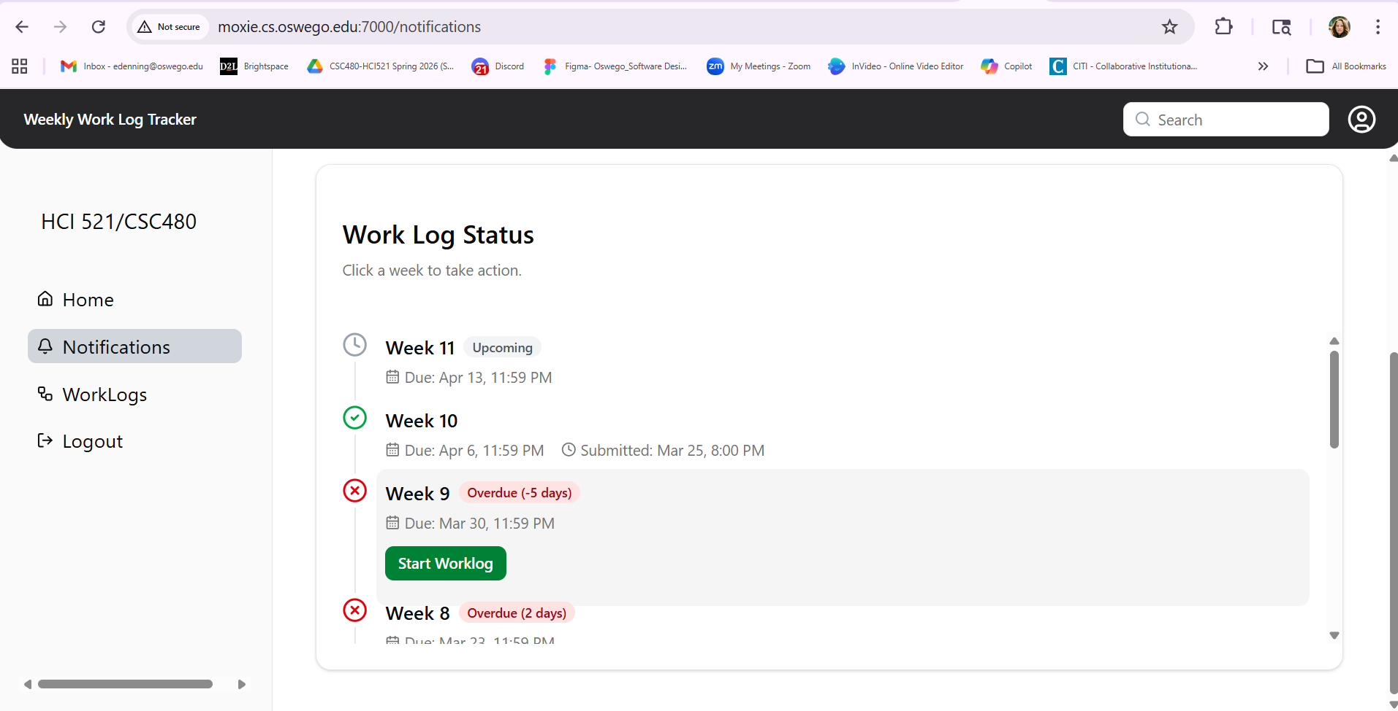

Screenshot # 2:
After submitting Week 9, the homepage showed that the submission was completed but didn’t indicate that it was late.


Screenshot # 3:
I tried to submit another overdue worklog (Week 8). Again, the homepage did not indicate that the worklog was overdue.
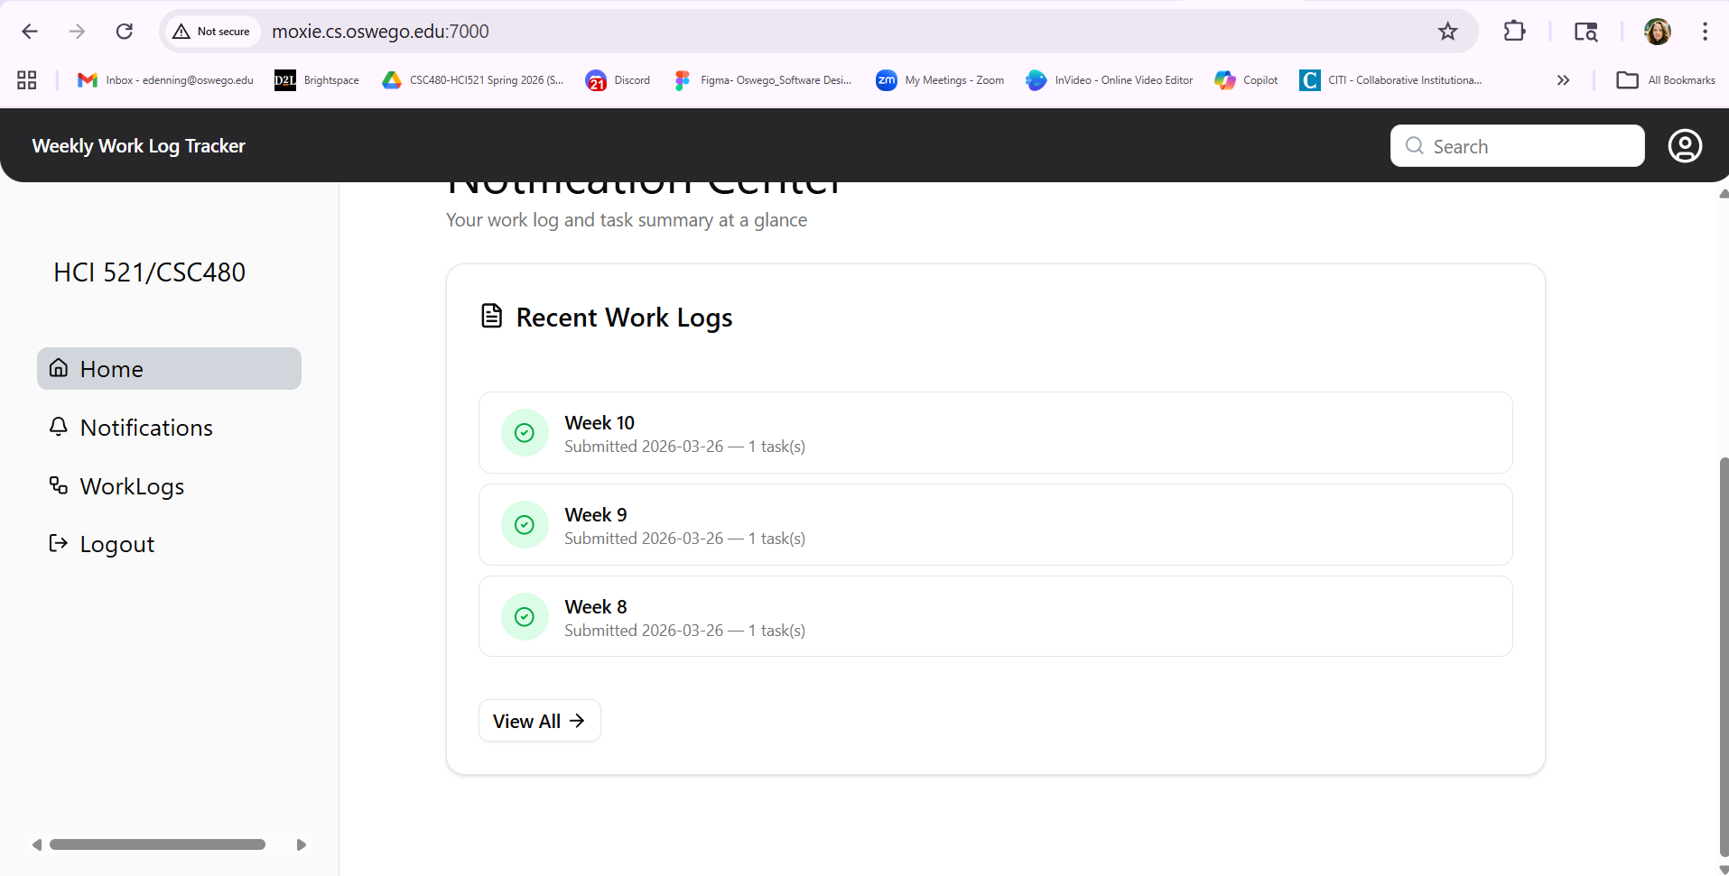

Screenshot # 4:
When I clicked on “View All”, the Week 9 worklog did not show that it was late but Week 8 successfully indicated that the submission was late.
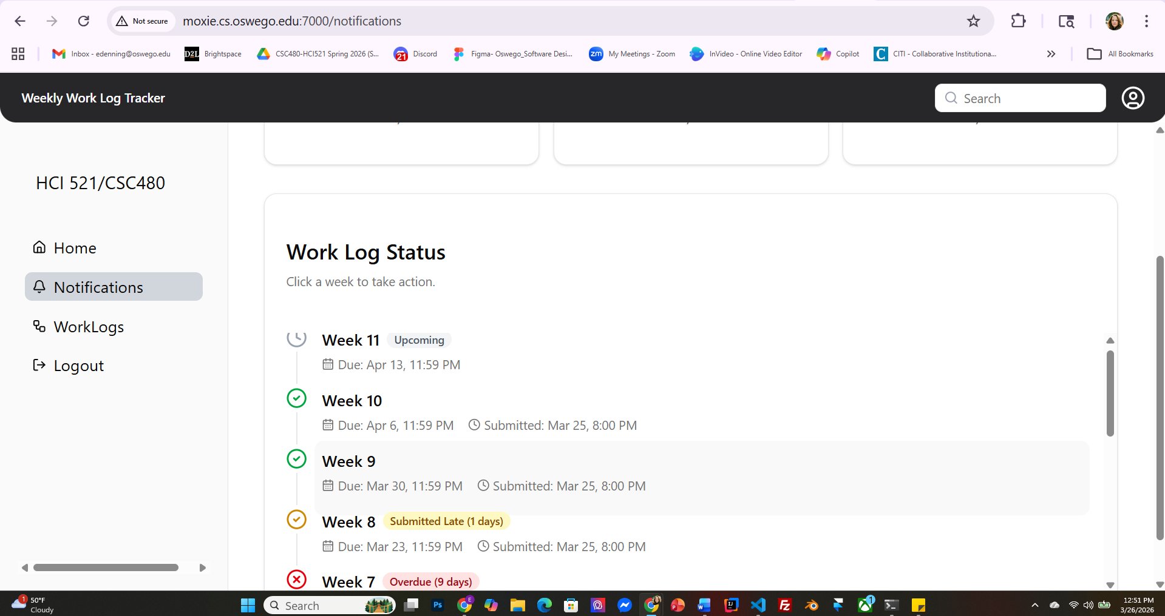

ST-1 BUGS
Bug/Defect # Defect-1

Severity: Low

STP Test Case # ST-1

Build/Release # v0.1.0_20260304

Steps during test:
- Open Chrome browser on Windows OS
- Navigate to Homepage on Moxie website
- Clicked on Continue this week’s worklog button
- Navigated to worklog page
- Filled in sample data leaving the reflection field blank
- The system successfully gave error feedback (Red color of text field, and red “Reflection” indicator
- The worklog page was not scrollable.

Description:
During FR-4.1/ST-1, we found that we can’t scroll the entire page but the Weekly worklog section is scrollable.

Potential Cause (if known):
Not sure, could be related to sizing or Windows/Chrome conversion

Screenshots of errors:

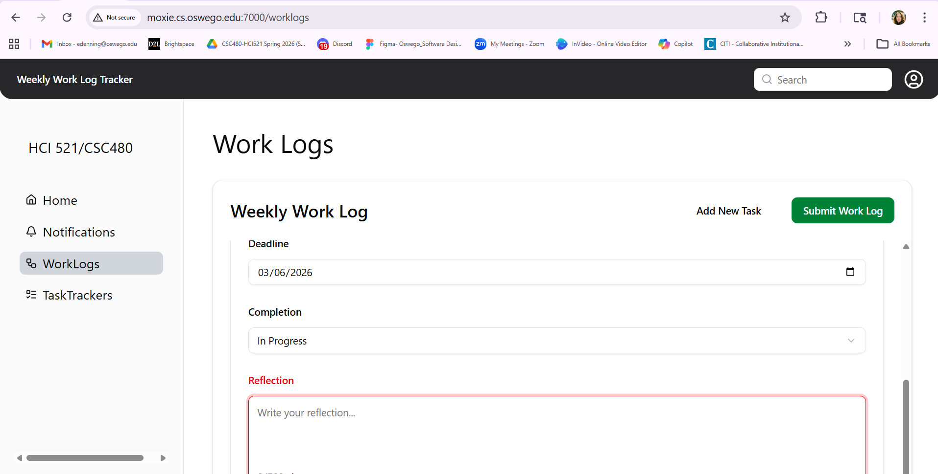

—----------------------------------------------------------------------------------------------------------------------------

Bug/Defect # Defect-2
Severity: Critical

STP Test Case # ST-1

Build/Release # v0.1.0_20260304

Steps during test:
- Open Chrome browser on Windows OS
- Navigate to Homepage on Moxie website

Description:
During ST-1, Mac OS (Safari browser) was successful loading homepage and worklog page
Windows OS (Chrome browser) was sometimes successful. The Moxie server became unreachable and unreliable to continue testing.

Potential Cause (if known):
Moxie server unreachable/unreliable in Chrome on Windows OS

Screenshots of errors:
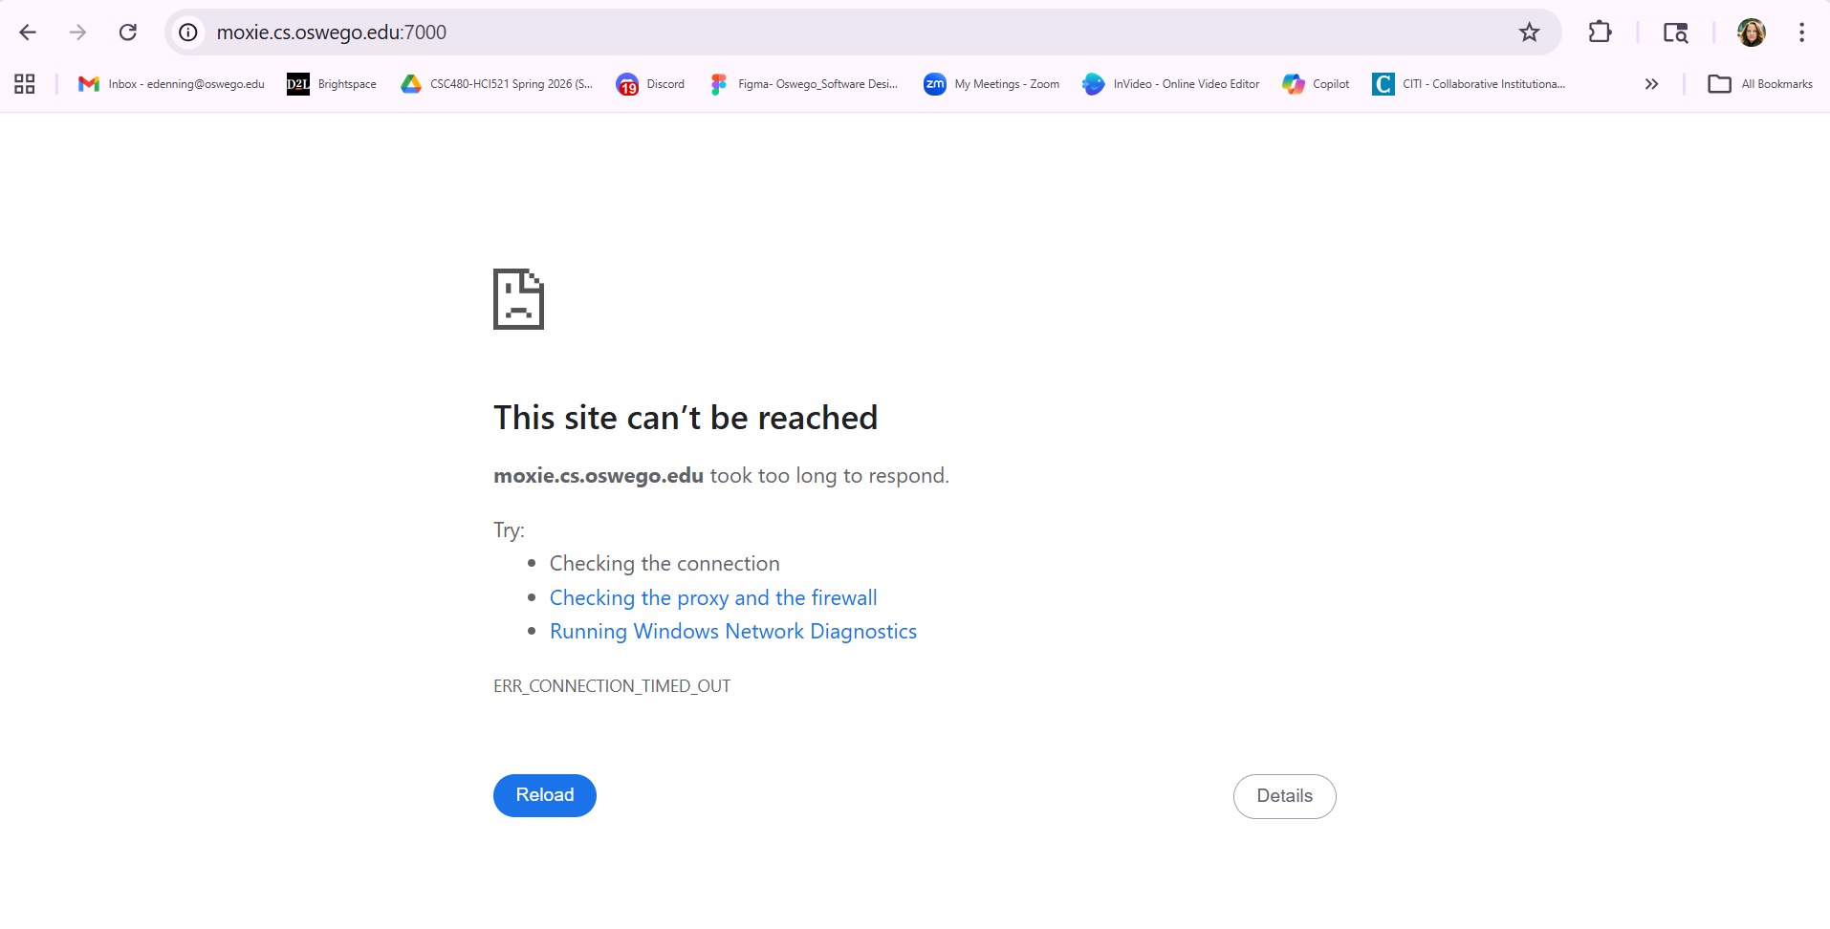
Homepage
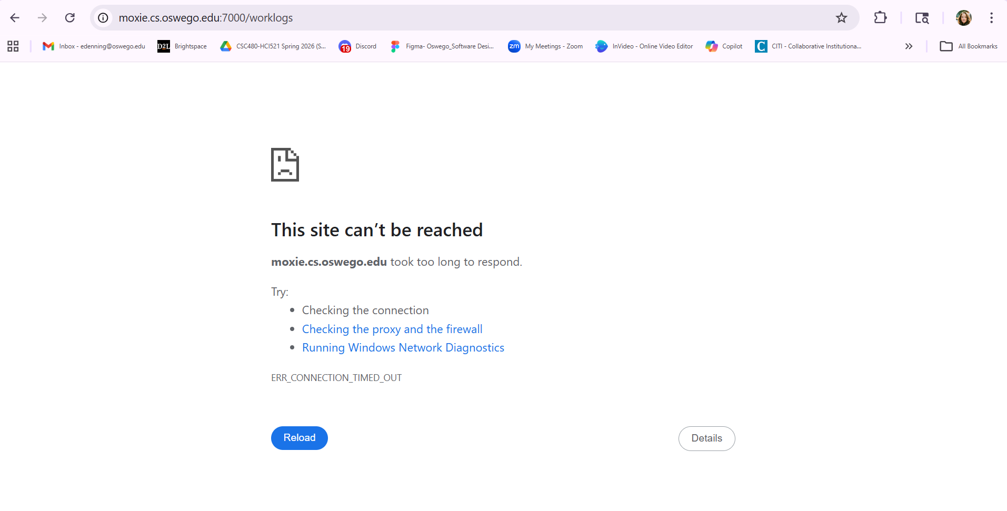
Worklogs page

—----------------------------------------------------------------------------------------------------------------------------

